# The Open Government Partnership: The local dimension

**Notes from presentation to Local Public Data Panel – 5th June 2013**



Tim Davies ([tim@practicalparticipation.co.uk](mailto:tim@practicalparticipation.co.uk))[1]

## Introduction

* **OGP was launched in 2011 as group of states committed to:**
  + Increase availability of information about government activities;
  + Support civic participation
  + Implement highest standards of professional integrity
  + Increase access to new technologies for openness & accountability
* **59 member countries, each with a National Action Plan on open government**
  + Containing concrete commitments
  + Commitments are audited by an Independent Review Mechanism
  + See [www.opengovpartnership.org](http://www.opengovpartnership.org) for details.
* **UK is a founder member, and currently lead co-chair of the OGP**
  + Produced first National Action Plan in 2011
  + Drafting new National Action Plan for October 2013 through an open policy making process with civil society
  + OGP guidance requires that plans are drawn up with involvement of civil society
* **The UK Civil Society Working Group on the Open Government Partnership** is an informal network, chaired by Involve, and including over 20 organizations with national and international focus, working to input into the OGP process.
  + Run through an open mailing list & open meetings
  + See [www.opengovernment.org.uk](http://www.opengovernment.org.uk) for details

## The local dimension:

Consultation on the plan has highlighted the importance of the local dimension: enabling people to have access to relevant local data, and to be engaged in using it to create change.

## The current draft

Awaiting sign-off to be published as a draft National Action Plan, and Annexe of additional commitments explored during drafting. Includes commitments on more open data, open contracting, new transparency initiatives (EITI, COST), and open data engagement.

The commitment draws upon a draft model developed at UK GovCamp 2012 described as the ‘5 stars of open data engagement’:

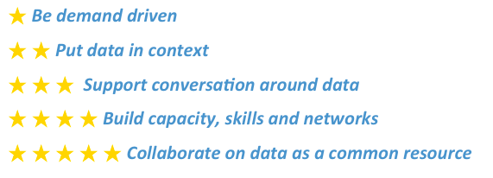

<http://www.opendataimpacts.net/engagement/>

Over the next three months there is scope to shape the details of National Action Plan commitments, identifying concrete measurable actions to be included in the plan or in accompanying strategy, and to use the opportunities of the Open Government Partnership global plenary meeting that will take place in London in October/November 2013 for raising the profile of, and sharing learning on, these commitments.

## Current draft NAP text on open data engagement:

**5 Stars of Open Data Engagement** - the UK government will support individuals, community groups and the voluntary sector to make effective use of open data by adopting the 5 stars of open data engagement and developing programmes and resources that promote the use of open data in particular settings - such as neighborhood planning, health service governance, and overseas aid.

## Questions:

* **What concrete actions, around open data engagement or other OGP themes, should the National Action Plan include that would further the work of the Local Public Data Panel?**
* **How could the current open policy making process around the National Action Plan better engage with the public data panels?**

1. Member of UK Civil Society Working Group on the Open Government Partnership.